Project Design Phase-II
Technology Stack (Architecture & Stack)

Date | 25 February 2026
Team ID | LTVIP2026TMIDS81684
Project Name | Calculating Family Expenses using ServiceNow
Maximum Marks | 4 Marks

Technical Architecture:
The Deliverable shall include the architectural diagram as below and the information as per the table1 & table 2
Example: Order processing during pandemics for offline mode
Reference: https://developer.ibm.com/patterns/ai-powered-backend-system-for-order-processing-during-pandemics/
Guidelines:
Include all the processes (As an application logic / Technology Block)
Provide infrastructural demarcation (Local / Cloud)
Indicate external interfaces (third party API’s etc.)
Indicate Data Storage components / services
Indicate interface to machine learning models (if applicable)


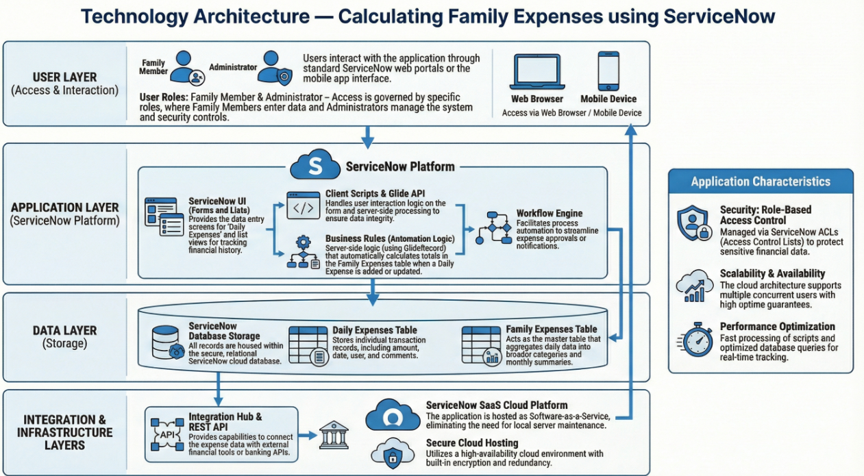

Table-1 : Components & Technologies:
S.No | Component | Description | Technology
1 | User Interface | How user interacts with application (forms, lists, dashboards) | ServiceNow UI (Forms & Lists)
2 | Application Logic-1 | Logic for expense entry and processing | ServiceNow Business Rules
3 | Application Logic-2 | Logic for automatic calculations | ServiceNow Server Scripts (Glide API)
4 | Application Logic-3 | Logic for workflow and automation | ServiceNow Script Engine
5 | Database | Data storage and configurations | ServiceNow Tables (Database)
6 | Cloud Database | Database service on cloud platform | ServiceNow Cloud Database
7 | File Storage | Storage of application data and records | ServiceNow Data Storage
8 | External API-1 | Integration capability if required | ServiceNow REST API
9 | External API-2 | External data communication support | ServiceNow Integration Hub
10 | Machine Learning Model | Not applicable in this project (optional automation possible) | Not Applicable
11 | Infrastructure (Server / Cloud) | Application deployed on ServiceNow cloud platform | ServiceNow SaaS Cloud Instance

Table-2: Application Characteristics:
S.No | Characteristics | Description | Technology
1 | Open-Source Frameworks | Platform uses built-in ServiceNow framework | ServiceNow Platform
2 | Security Implementations | Role-based access control and authentication | ServiceNow ACL & Roles
3 | Scalable Architecture | Cloud-based scalable architecture supporting multiple users | ServiceNow Cloud Architecture
4 | Availability | High availability through cloud hosting | ServiceNow SaaS Platform
5 | Performance | Optimized database and fast processing | ServiceNow Optimized Database

References:
https://c4model.com/
https://developer.ibm.com/patterns/online-order-processing-system-during-pandemic/
https://www.ibm.com/cloud/architecture
https://aws.amazon.com/architecture
https://medium.com/the-internal-startup/how-to-draw-useful-technical-architecture-diagrams-2d20c9fda90d

